**TEAM ID** : PNT2022TMID18458

**PROJECT NAME** : IOT Based Safety Gadget for Child Safety Monitoring and Notification

# INTRODUCTION

* 1. **Project Overview**

The term "internet of things" (IoT) describes a collection of hardware and software that connects to the internet and real-world sensors. The safety of children is in danger today more than ever, so it's critical to offer them a technology-based solution that will support them in emergency circumstances and allow for smart device monitoring. The proposed system uses IoT and sends all the monitoring metrics to the cloud for android app monitoring on the parental phone. It is equipped with GSM and GPS modules for alarm sending and receiving between safety device and parental phone. Using the GPS coordinates on the parental phone's android app, an Android application can be used to track the current location of a safety device. It emphasizes on the crucial idea that a missing child can be helped by those who are close to them and can play a significant part in ensuring their safety until they are reunited with their parents. Additionally, it updates the parental app via the cloud.

# Purpose

These days, kids lack a sense of security and face numerous security-related challenges. Many family members spend more time working and fulfilling their societal obligations, which include caring for their children. The situation in our nation right now is unsuitable for keeping an eye on kids. It is challenging to keep an eye on the kids constantly in the absence of a child surveillance system. Where Young children may act impulsively and choose impulsive locations. Most of the human behaviour is formed during the formative years, necessitating the need of a child monitoring system. Accidents and events frequently involve children. Due to their inability to defend themselves, children's safety is essential. Kids are the lifeblood of any parent, as we all know, and parents need to take particular care with children who have special needs. They must give their youngster special attention.

* Parents may always follow their children’s whereabouts with the aid of a child tracker.
* They may easily set up a geofence around the site and leave their kids in play areas or schools.
* If the child crosses the geofence, alerts will be generated by continuously monitoring the child's position. Parents or caregivers will receive notifications based on the child's location.
* The database will contain all the location information.
* Enable the tracking of the child's location and the remote collection of data, including the child's position and other factors to display actual data from the child together with reference values.
* Enable notification transmission if the youngster is missing or if the device detects an unusual circumstance or condition.

# LITERATURE SURVEY

* 1. **Existing problem**

Kids are the lifeblood of any parent, as we all know, and parents need to take particular care with children who have special needs. They must give their youngster special attention. Parents may always follow their children’s whereabouts with the aid of a child tracker. They only need to set up a geo-fence around the site and leave their kids in play areas or schools. If the child crosses the geo-fence, notifications will be generated by continuously monitoring the child's position. Parents or caregivers will receive notifications based on the child's location. The database will contain all the location information. If there is a danger, the child can also alert the parents in an emergency.

This study shows how smart IoT devices can be used to track and protect children while also assisting parents in finding and keeping an eye on them. Alerts sent to mobile phones if the sensor detects any unusual readings. updated the parental app over the cloud as well. For communication between the safety device and the parent's phone, the system has GSM and GPS modules. The IoT system also includes a Wi-Fi module that transmits all the tracked parameters to the cloud for parental phone android app monitoring.

# References

* + 1. Mahajabeen Budebhai, "IOT based child and women protection", *International Journal of computer science and mobile Computing*, no. 7, pp. 141-146, August 2018.
    2. Jonnadulal, Bhanu Prasad Davu, Hari Kishore Kandula, Vinod Donepudi, Sivaiah Etukuri and Gopinadh, "Child security wearable gadget", *VVIT Guntur Andhra Pradesh India Global Journal for Research in Applied Science and Engineering Technolgy(IJRASET)*, vol. 6, no. 2, February 2018.
    3. Cassandra Dsouza, Dhanashree Rane, Anjanette Raj, Supriya Murkar and Namita Agarwal, "Design of Child Security Method", *International conference for convergence in tehnology*, 2018.

1. Moodbidri, A., Shahnasser, H.: Child safety wearable device. In: 2017 International Conference on Information Networking (ICOIN), pp. 438–444. IEEE (2017)
2. Niti shree, "A review on IOT Based Smart GPS device for Child and Women Safety applications", *International journal of engineering research and general science*, no. 4, May-June 2016.
3. Jatti Anand, Kannan Madhvi, M Alisha, R Vijayalakshmi and P Sinha, Structure and improvement of an IOT based wearable gadget for the wellbeing and security of ladies and young lady youngsters, 2016.

7. Huang, Z., Gao, Z., Lu, H., Zhang, J., Feng, Z., Xia, H.: An mobile safety monitoring system for children. In: 10th International Conference on Mobile Ad- hoc and Sensor Networks, pp. 323–328. IEEE (2014)

# Problem Statement Definition

Create a problem statement to understand your customer's point of view. The Customer Problem Statement template helps you focus on what matters to create experiences people will love. A well-articulated customer problem statement allows you and your team to find the ideal solution for the challenges your customers face. Throughout the process, you’ll also be able to empathize with your customers, which helps you better understand how they perceive your product or service.

**Customer Problem Statement Template:**

|  |  |  |  |  |  |
| --- | --- | --- | --- | --- | --- |
| **Problem Statement (PS)** | **I am (Customer)** | **I’m trying to** | **But** | **Because** | **Which makes me feel** |
| PS-1 | Parent | To detect child location | lack of information n about child location | Because the location of the child is not exactly known by the parent | Frightening, scary  , fearful , uneasy , worry, terrifying , unpleasant , anxious |

# IDEATION & PROPOSED SOLUTION

* 1. **Empathy Map Canvas**

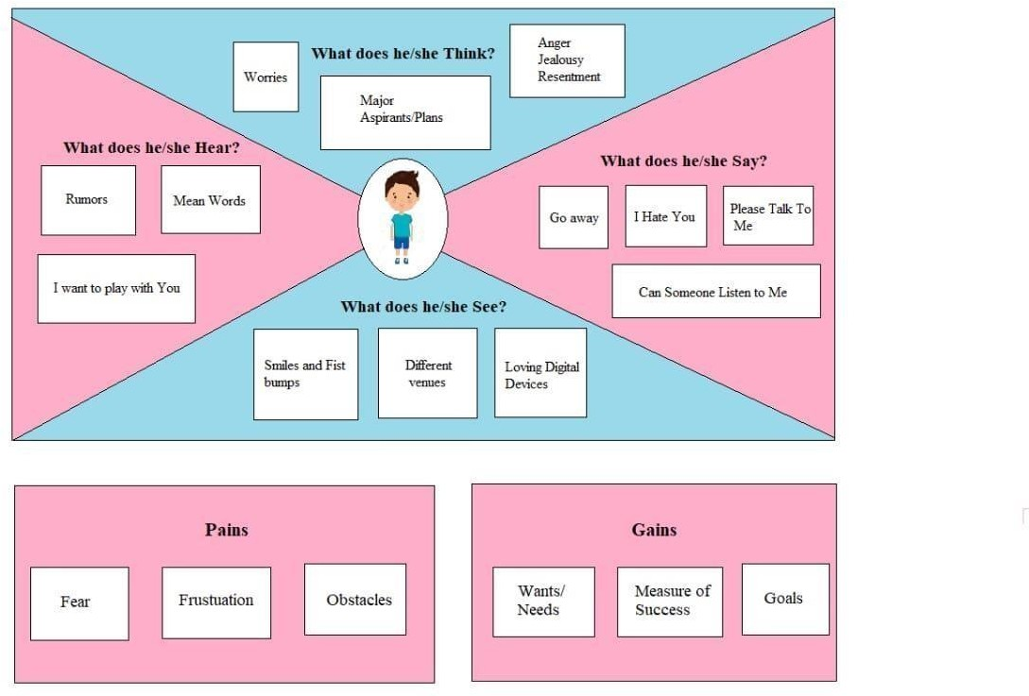

# Ideation & Brainstorming

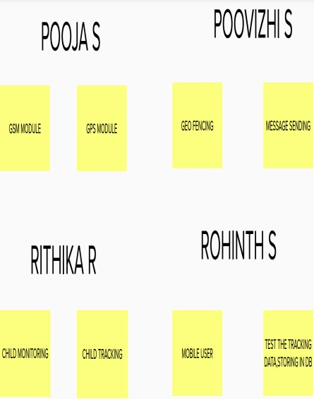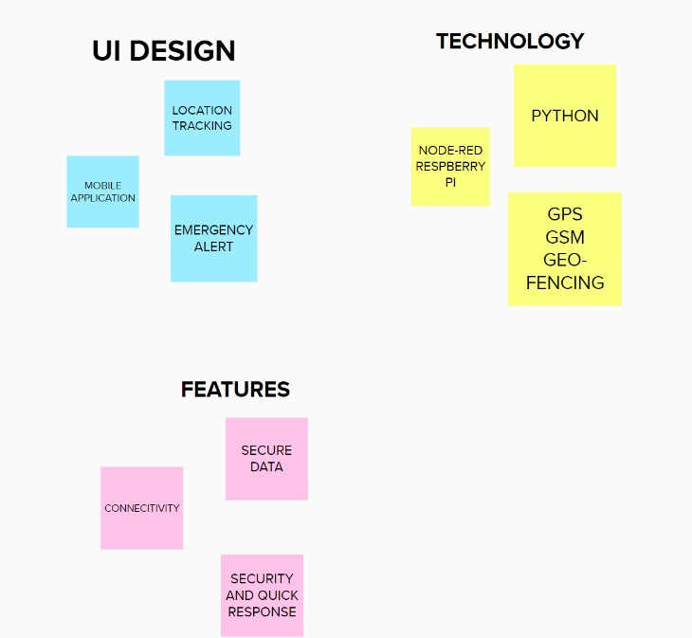

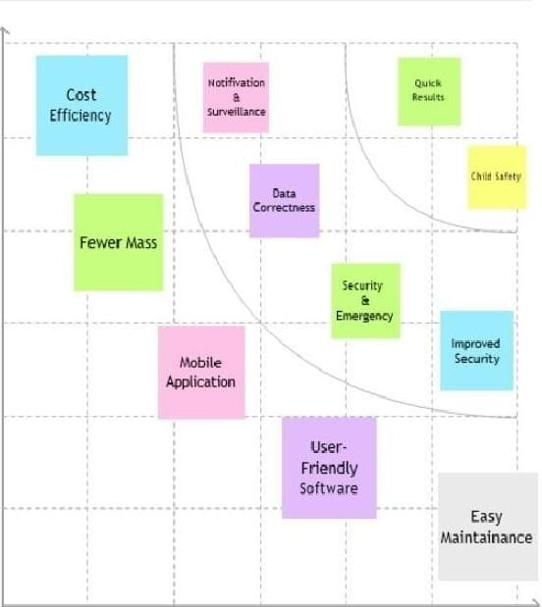

* 1. **Proposed Solution**

# Proposed Solution Template:

|  |  |  |
| --- | --- | --- |
| **S. No** | **Parameter** | **Description** |
| 1. | Problem Statement (Problem to be solved) | Prepare a device which is used to track the child and to notify it to their parents |
| 2. | Idea / Solution description | We are going to prepare a device which sends the current location of the children and also parents can make a geofence to protect their  child |
| 3. | Novelty / Uniqueness | Geofence - Parent can create a geofence at specified time like scheduling activities so that they can accurately monitor their children |
| 4. | Social Impact / Customer Satisfaction | It is very compact and with good quality. It can be easily affordable by all. |
| 5. | Business Model (Revenue Model) | Collected data can be used to predict the flow of children. |
| 6. | Scalability of the Solution | The model can be able to handle many number of input and provides the respective output. |

* 1. **Problem Solution fit**

# REQUIREMENT ANALYSIS

* 1. **Functional requirement:**

Following are the functional requirements of the proposed solution.

|  |  |  |
| --- | --- | --- |
| **FR No.** | **Functional Requirement (Epic)** | **Sub Requirement (Story / Sub-Task)** |
| FR-1 | User Registration | Registration through Form Registration through Gmail |
| FR-2 | User Confirmation | Confirmation via Email Confirmation via OTP |
| FR-3 | Notification | Notified via Mobile Web app |
| FR-4 | User Interface | Mobile Web App user can create the geofence |
| FR-5 | User Interface | Mobile Web App user able to see location of children when they are out of geofence |

# Non-functional Requirements:

Following are the non-functional requirements of the proposed solution.

|  |  |  |
| --- | --- | --- |
| **FR No.** | **Non-Functional Requirement** | **Description** |

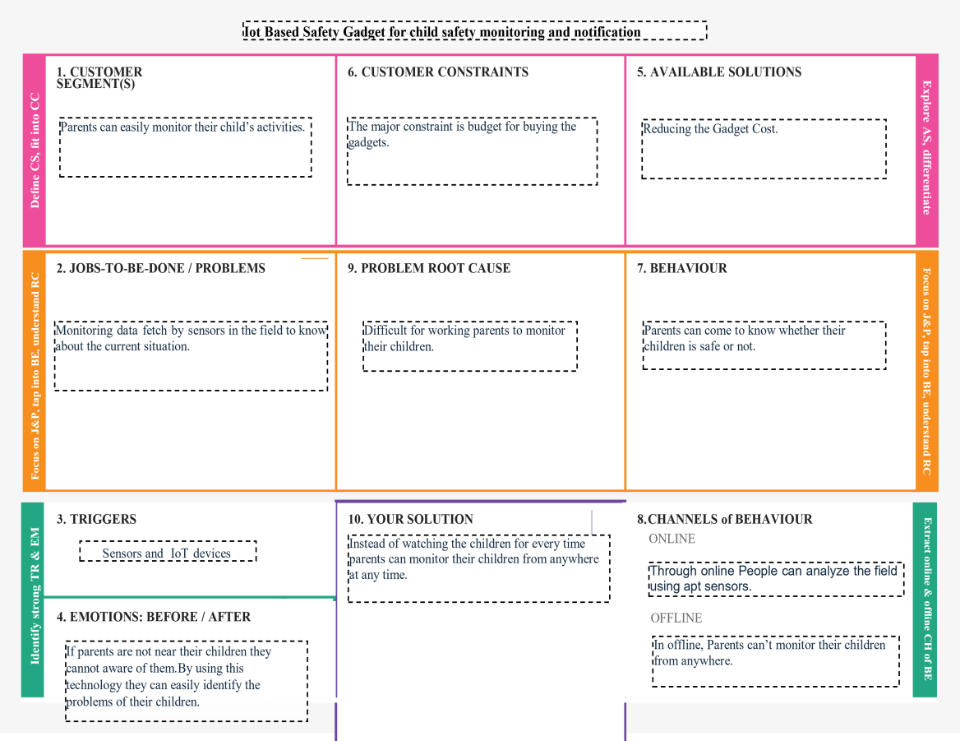

|  |  |  |
| --- | --- | --- |
| NFR-1 | **Usability** | Accessed through Mobile Web app Showing location of the child |
| NFR-2 | **Security** | Database security must meet HIPAA requirements |
| NFR-3 | **Reliability** | Once logged in, webpage is available until logging out of app |
| NFR-4 | **Performance** | Each page must load with minimum time |
| NFR-5 | **Availability** | Must be active throughout the day and remain active at least a week for a single charge. |
| NFR-6 | **Scalability** | The process must finish within 3 hours so data is available in the morning after an overnight update |

# PROJECT DESIGN

* 1. **Data Flow Diagrams**

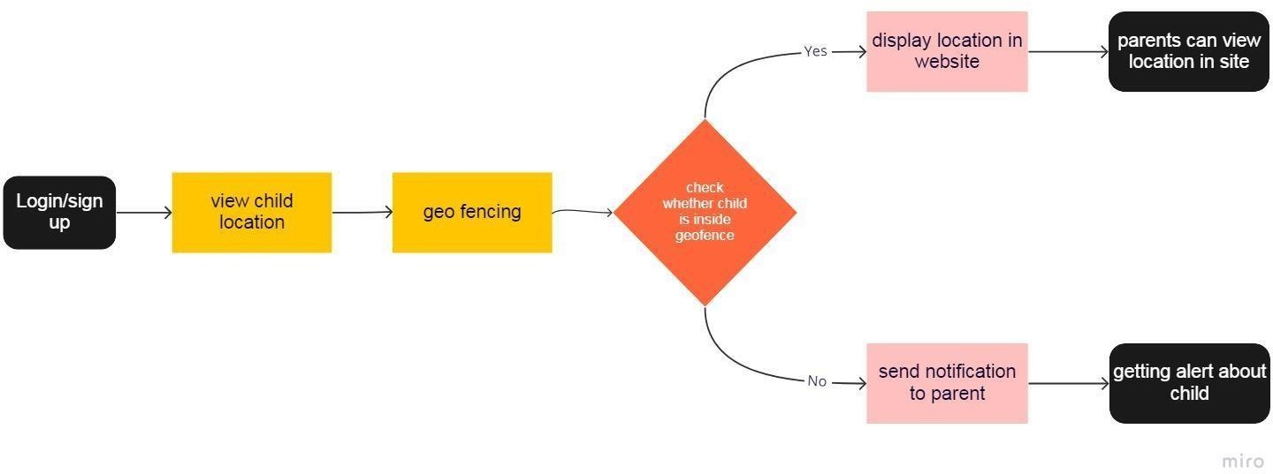

* 1. 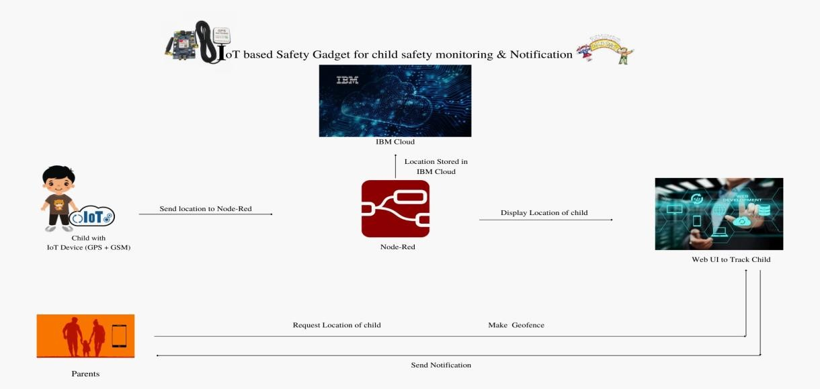**Solution & Technical Architecture Technical Architecture:**

**Table-1 : Components & Technologies:**

* 1. **User Stories**

**User TSyp.Ne**

**o**

**CFoumncptoionneanl t**

**Requirement**

**User Story**

**DesUcsreipr tSiotonry / Task**

**Acceptance criteria**

**TePcrhionroitlyogRyelease**

* + 1. U**(**s**E**e**p**r**ic**In**)** terface

**Numb**W**er**eb UI

HTML, CSS,

Customer

login/sign up

USN-1

User can

I can access

JaHviagShcript Sprint-

* + 1. Application Logic-1 StorreinggisLteorcfaortiothne in mIByMacCcloouundt / Python 1
    2. Application Logic-2

Sh application by ti

dashboard

HTML / CSS /

owing the loca

entering my

Web UI

on in the

JS

4.

5.

Custom6er.

Application Logic-3 Database

CTloraucdkiDngatabase

email,

MakpiansgswGoerdo, faenndce

Objceocnt firming my password.

USN-2DatUabsearsceanSevirevwice oIncCanlovuiedw

Node Red , JS NoSQL

IBHMigChloudaSnptrint-

1. Machine Learning Model

Purlpoocsaetioonf iMn athcehineloLceataiornning Modweelbsite

Object 2

Recognition

Customer Geo fence

USN-3 User can make Geo fence

MHodigehl, etc.Sprint-

1. Infrastructure (Server / Cloud)

AppgliecoafteionnceDfeorploymcreenatteodn Loctahle child

Python (Loc3al) / IBM cloud

Customer

Notification

USN-4SysItfetmhe/cChiloldud Notification (CHloiguhdant) Sprint-

LocwaleSnteoruvtefrroCmonfigruecraeitvioend: 4

Clouthde SfeenrcveetrhCe onfiguration:

user can get

notification

# PROJECT PLANNING & SCHEDULING

* 1. **Sprint Planning & Estimation**

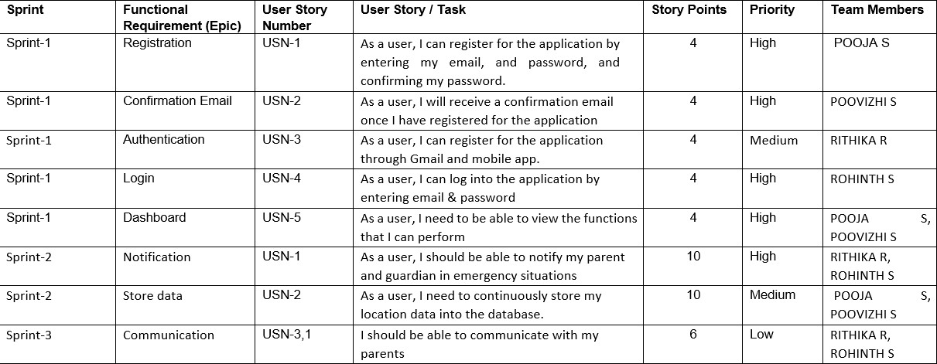

* 1. **Sprint Delivery Schedule**

**Project Tracker, Velocity & Burndown Chart: (4 Marks)**

|  |  |  |  |  |  |  |
| --- | --- | --- | --- | --- | --- | --- |
| **Sprint** | **Total Story Points** | **Duration** | **Sprint Start Date** | **Sprint End Date (Planned)** | **Story Points Completed (as on Planned End**  **Date)** | **Sprint Release Date (Actual)** |
| Sprint- 1 | 20 | 6 Days | 24 Oct 2022 | 29 Oct 2022 | 20 | 29 Oct 2022 |
| Sprint- 2 | 20 | 6 Days | 31 Oct 2022 | 05 Nov 2022 | 20 | 05 Nov 2022 |
| Sprint- 3 | 20 | 6 Days | 07 Nov 2022 | 12 Nov 2022 | 20 | 12 Nov 2022 |
| Sprint- 4 | 20 | 6 Days | 14 Nov 2022 | 19 Nov 2022 | 20 | 19 Nov 2022 |

**Velocity:**

**Average Velocity = 61/24 = 2.51**

* 1. **Reports from Jira**

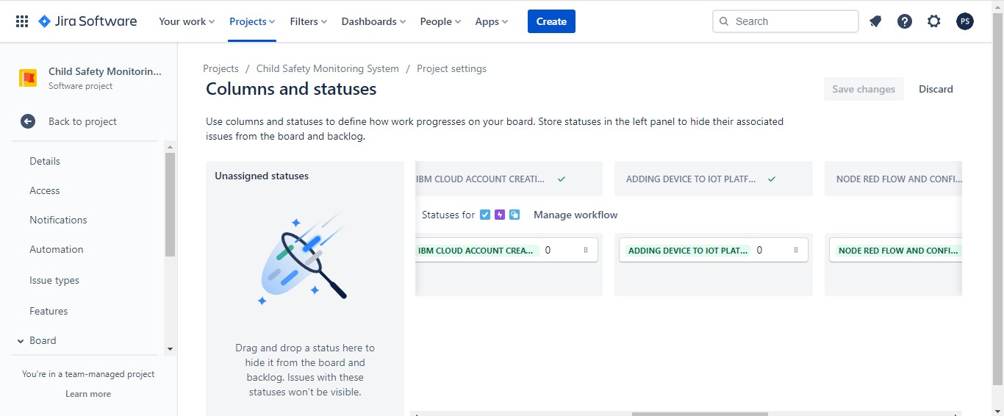

# CODING & SOLUTIONING

* 1. **Feature 1**

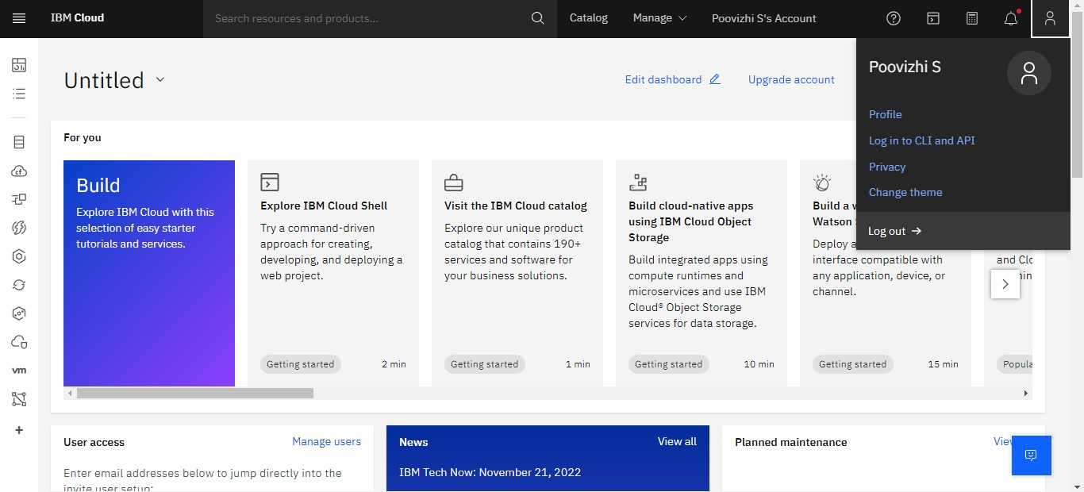**Creating IBM Cloud Account**

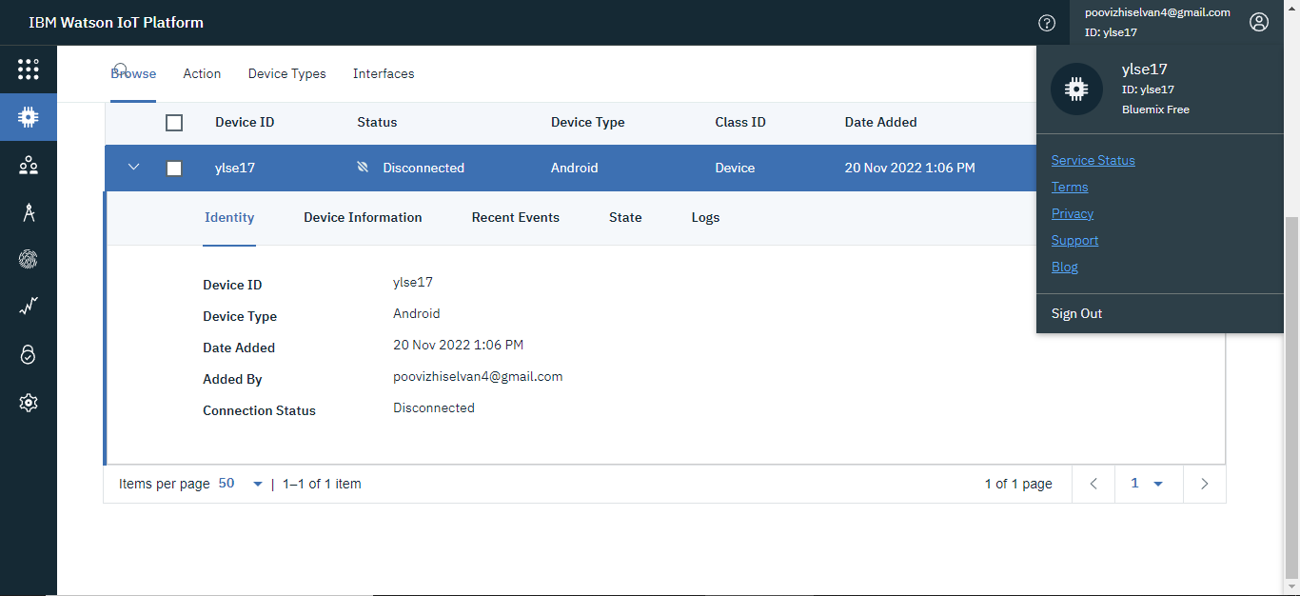**Connecting the Device in IOT Watson Platform**

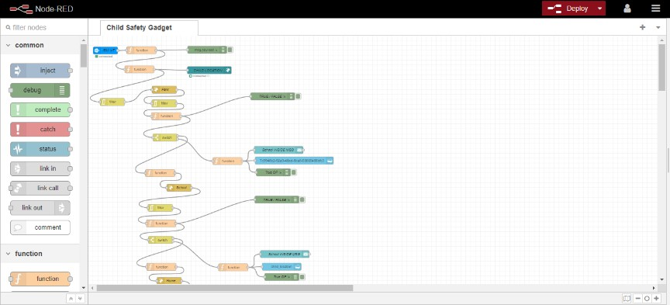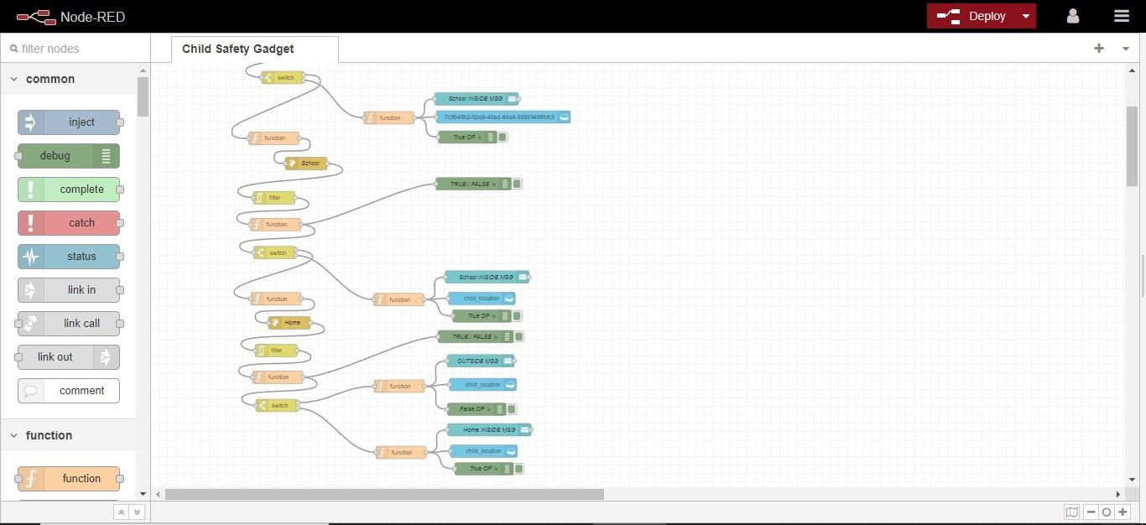**Developing Node Red flow and Connecting it to the IOT Device**

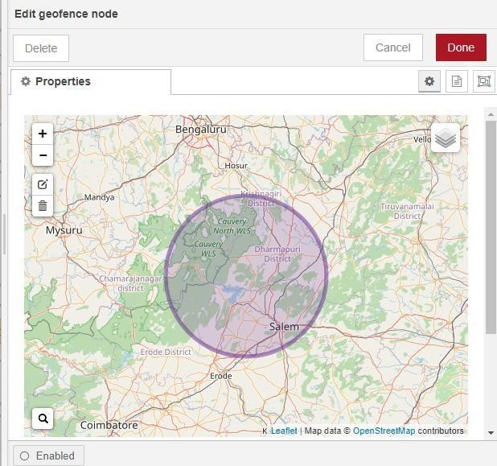**Created the Geofence in Node Red**

Code: [Python](https://github.com/IBM-EPBL/IBM-Project-55058-1663656092/blob/main/Project%20Developement%20Phase/Sprint%203/app.py), Node Red, JavaScript, IBM Cloudant

* 1. **Feature 2**

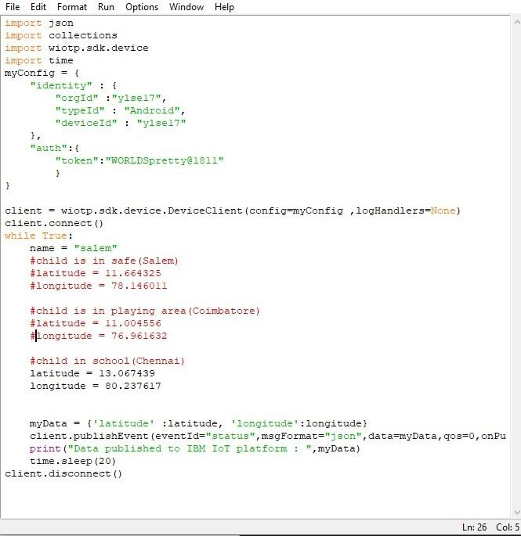**Added code to get child location in python using IDLE**

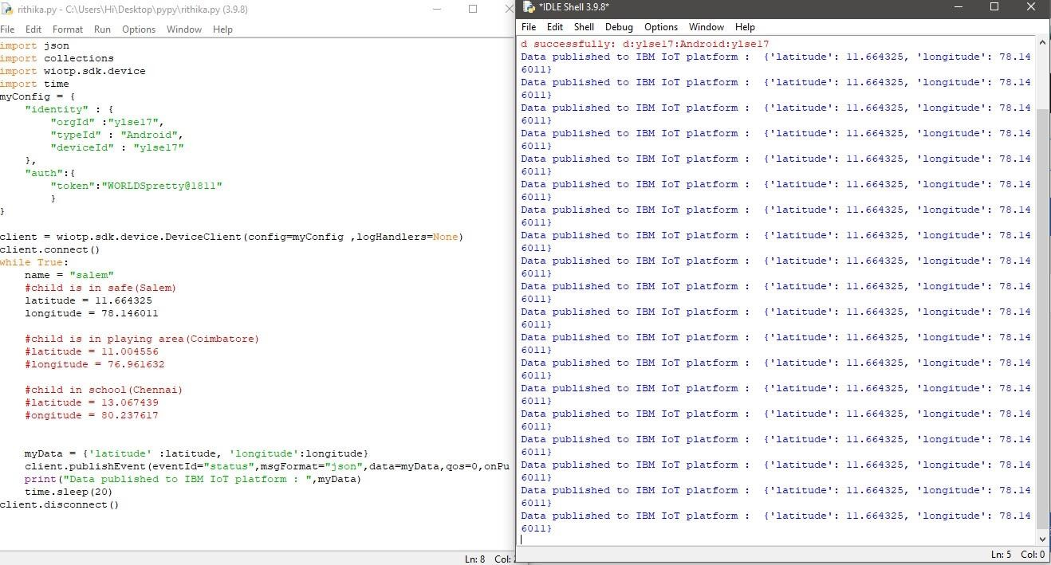**Running the Python Script to send requests to IBM Watson**

**Information From Python Script is Received by IBM Watson(Recent Location)**

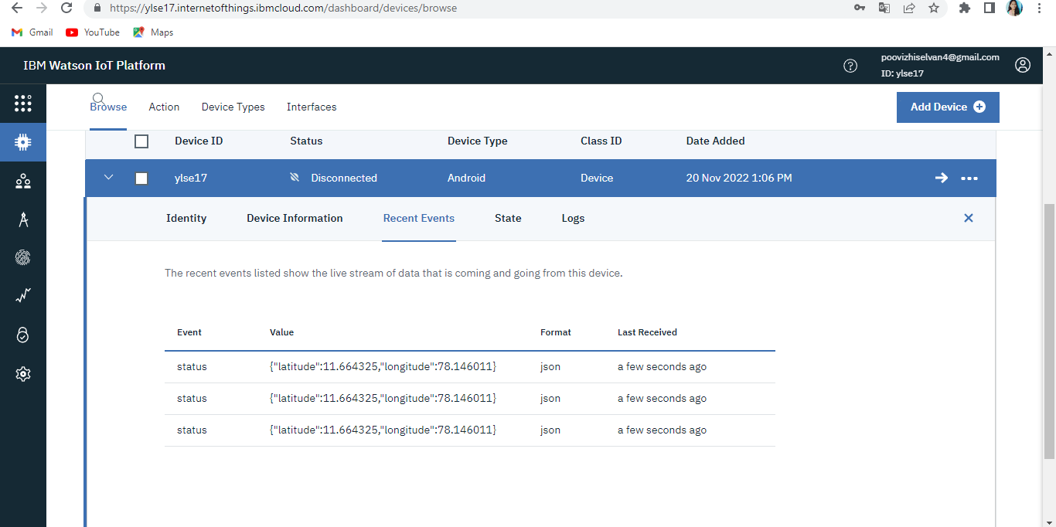

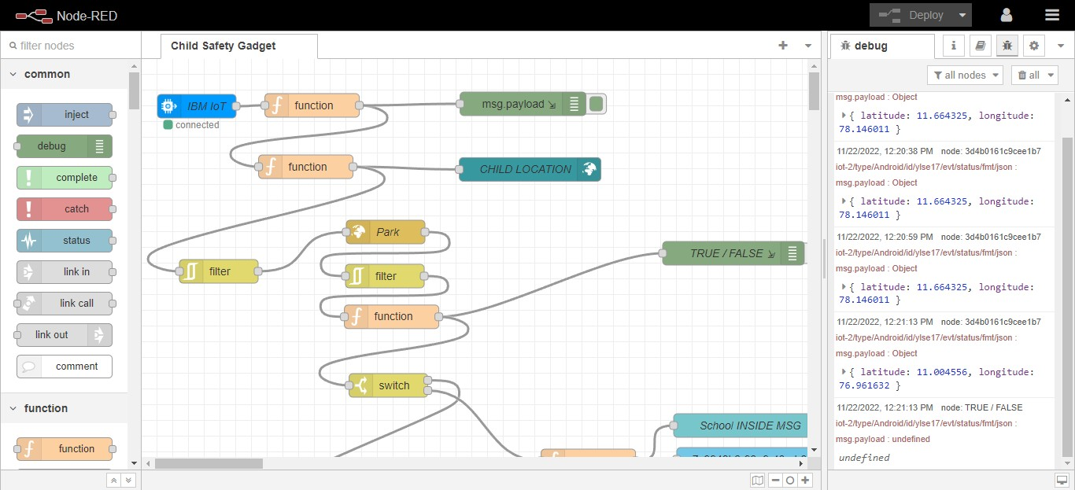**Information Received by Node Red from Watson device**

**Located the Child in UI Dashboard**

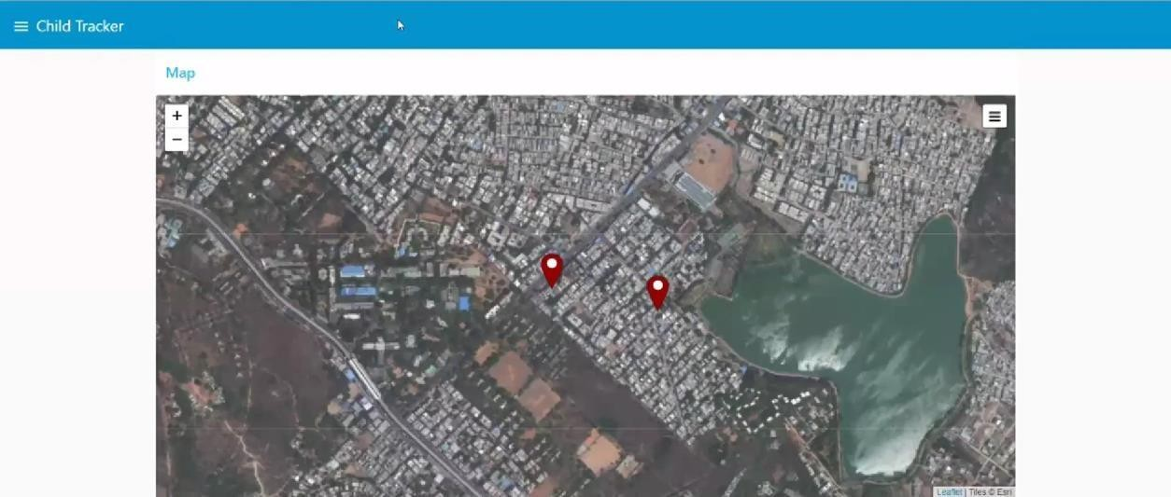

Code: [HTML](https://github.com/IBM-EPBL/IBM-Project-55058-1663656092/tree/main/Project%20Developement%20Phase/Sprint%203/templates), [CSS](https://github.com/IBM-EPBL/IBM-Project-55058-1663656092/tree/main/Project%20Developement%20Phase/Sprint%203/static), [Python](https://github.com/IBM-EPBL/IBM-Project-55058-1663656092/blob/main/Project%20Developement%20Phase/Sprint%203/app.py), JavaScript

# ADVANTAGES & DISADVANTAGES

**Advantages:**

1. A Child's GPS Tracker reports any potential dangers and protects them in the process.
2. It acts as a communication tool for parents and can be helpful even when traveling.
3. Usually, children tend to wander a lot. With the help of GPS Tracking devices, you can easily and quickly know where your children are.
4. Parents will get all the details like their kid boarding/de- boarding school bus. Also, they can get emergency alerts when the child fails to board or de-board at the other stop.
5. Prevent abduction and let your children play and walk around safely. Our Personal GPS trackers for kids are great options for parents for monitoring their children 24/7.

**Disadvantages:**

1. Young children may refuse to cooperate unless allowed to play with their gadgets.
2. Excess use of electronic gadgets can lead to children spending less time outdoors and limiting their social interaction.
3. It may lead to poor concentration in studies and lack of interest in day to-day activities.
4. [Excessive gadgets use c](https://www.parentcircle.com/how-to-balance-excess-gadget-use-in-kids-with-other-activities/article)an lead to poor health, a sedentary lifestyle, and bad eating habits.

# CONCLUSION

This Android Device has a superior mode for viewing and locating the children where about with correct latitude and longitude, which is especially useful when using Google maps. This could assist to reduce the number of attacks on children while also making them feel protected and secure. The major goal of this project is to create a device that protects youngsters from risky circumstances while also assisting them in combating them.

# FUTURE SCOPE

A camera module for surveillance of the child's surrounds can be added to improve the system's performance. It's also possible to do it with a Raspberry Pi and Lily pad. It is possible to develop a more energy-efficient type that can keep the battery for a longer period.

This system can be further enhanced by installation of mini camera inside smart gadget for better security so that live footage can be seen on parental phone during panic situations. The system can be modified by installation of small solar panels for charging the battery of smart gadget to gain maximum battery backup.

For surveillance of the child's surroundings, to get a clearer picture of the location, this wearable can also contain a camera module incorporated in it. The camera will be collecting information in the same manner as the GPS module. It will be on standby conserving power waiting for the particular keyword "SNAPSHOT" to be sent from the user's smart phone to the GSM shield will activate the camera to start clicking a snapshot of the surrounding and save the file temporarily on the external micro-SD card. After which Arduino UNO will access the saved image from the micro SD storage and transfer it to the GSM module which send it to the user via SMS/MMS text.

# APPENDIX

**Source Code: Python Script**

import json import collections

import wiotp.sdk.device import time

myConfig = { "identity" : {

"orgId" :"ylse17",

"typeId" : "Android", "deviceId" : "ylse17"

},

"auth":{

"token":"WORLDSpretty@1811"

}

}

client = wiotp.sdk.device.DeviceClient(config=myConfig ,logHandlers=None) client.connect()

while True:

name = "salem"

#child is in safe(Salem) #latitude = 11.664325

#ongitude = 78.146011

#child is in playing area(Coimbatore) latitude = 11.004556

longitude = 76.961632

#child in school(Chennai) #latitude = 13.067439

#ongitude = 80.237617

myData = {'latitude' :latitude, 'longitude':longitude}

client.publishEvent(eventId="status",msgFormat="json",data=myData,qos=0,onPublish=Non e)

print("Data published to IBM IoT platform : ",myData) time.sleep(20)

client.disconnect()

**Flows.json**

[{"id":"17d65b6695af9309","type":"tab","label":"Child Safety Gadget","disabled":false,"info":"","env":[]},{"id":"ee3e34b6d639d979","type": "ibmiot in","z":"17d65b6695af9309","authentication":"apiKey","apiKey":"63d0c89133 a32847","inputType":"evt","logicalInterface":"","ruleId":"","deviceId":"childlo cation","applicationId":"","deviceType":"Child_Location","eventType":"+","co mmandType":"","format":"json","name":"IBM IoT","service":"registered","allDevices":"","allApplications":"","allDeviceType s":false,"allLogicalInterfaces":"","allEvents":true,"allCommands":"","allFormat s":"","qos":0,"x":67.60000610351562,"y":59.400001525878906,"wires":[["2a1

6cad9069e787b"]]},{"id":"1af1bd8990586025","type":"debug","z":"17d65b669 5af9309","name":"","active":true,"tosidebar":true,"console":true,"tostatus":false

,"complete":"payload","targetType":"msg","statusVal":"","statusType":"auto"," x":484.6000061035156,"y":57.000003814697266,"wires":[]},{"id":"2a16cad90

69e787b","type":"function","z":"17d65b6695af9309","name":"","func":"var name = 'SAV'\nvar lat = msg.payload.latitude\nvar lon = msg.payload

.longitude\nglobal.set('latitude',lat)\nglobal.set('longitude',lon)\nglobal.set('name ',name)\nreturn msg;\n","outputs":1,"noerr":0,"initialize":"","finalize":"","libs":[],"x":216.6000 0228881836,"y":59.000003814697266,"wires":[["148e7f1628ced498","1af1bd8

990586025"]]},{"id":"148e7f1628ced498","type":"function","z":"17d65b6695a

f9309","name":"","func":"msg.payload={\n 'name': 'SAV',\n 'lat': msg.payload.latitude,\n 'lon': msg.payload.longitude\n}\nreturn msg;\n\n","outputs":1,"noerr":0,"initialize":"","finalize":"","libs":[],"x":208.600 00610351562,"y":137.00000190734863,"wires":[["13144e7df427e65d","8bf33

eac23cb25f9"]]},{"id":"ee3df70f348f8f21","type":"function","z":"17d65b6695a f9309","name":"","func":"msg.payload = msg.location.inarea\nreturn msg;\n","outputs":1,"noerr":0,"initialize":"","finalize":"","libs":[],"x":317.6000 0228881836,"y":327.80002212524414,"wires":[["5314cfae47e464fa","1360f15

6eeea5fd0"]]},{"id":"1360f156eeea5fd0","type":"switch","z":"17d65b6695af93 09","name":"","property":"payload","propertyType":"msg","rules":[{"t":"false"

},{"t":"true"}],"checkall":"true","repair":false,"outputs":2,"x":313.6000022888 1836,"y":415.00004863739014,"wires":[["10a8e132a189623a"],["7fd9ee8387f

7e3ab"]]},{"id":"7fd9ee8387f7e3ab","type":"function","z":"17d65b6695af9309 ","name":"","func":"var d = new Date();\nvar utc = d.getTime() + (d.getTimezoneOffset()*60000);\nvar offset = 5.49;\nnewDate = new Date(utc

+ (3600000*offset));\nmsg.payload = {\n \"message\" : \"Exit\",\n \"Time\" : newDate.toLocaleString(),\n \"name\" : 'SAV',\n \"status\" : \"School\",\n 'lat': global.get(\"latitude\"),\n 'lon': global.get(\"longitude\"),\n \"nam\" : global.set('name'),\n \"sts\" : global.set('status')\n};\nreturn msg;\n","outputs":1,"noerr":0,"initialize":"\n","finalize":"","libs":[],"x":567.600

0022888184,"y":511.000057220459,"wires":[["7982bcc9dcd368ca","a5cc86db

a4b4725d","07a6f2efe6f67255"]]},{"id":"7982bcc9dcd368ca","type":"debug"," z":"17d65b6695af9309","name":"True OP","active":true,"tosidebar":true,"console":true,"tostatus":false,"complete":"pa yload","targetType":"msg","statusVal":"","statusType":"auto","x":754.6000595

092773,"y":557.0000448226929,"wires":[]},{"id":"13144e7df427e65d","type":

"ui_worldmap","z":"17d65b6695af9309","group":"fe4024ee907de35b","order": 0,"width":"0","height":"0","name":"CHILD LOCATION","lat":"","lon":"","zoom":"16","layer":"OSMG","cluster":"","maxa

ge":"","usermenu":"hide","layers":"hide","panit":"true","panlock":"false","zoo

mlock":"true","hiderightclick":"false","coords":"none","showgrid":"false","sho

wruler":"true","allowFileDrop":"true","path":"/worldmap","overlist":"DR,CO,R A,DN,BU,TL,HM","maplist":"OSMG,OSMC,EsriC,EsriS,EsriT,EsriDG,UKOS

","mapname":"","mapurl":"","mapopt":"","mapwms":false,"x":493.6000823974

6094,"y":140.40001392364502,"wires":[]},{"id":"5ce947f449d77406","type":"

geofence","z":"17d65b6695af9309","name":"School","mode":"circle","inside": "both","rad":4001.786630911072,"points":[],"centre":{"latitude":10.761304268 865539,"longitude":78.64700317382812},"floor":"","ceiling":"","worldmap":fa lse,"outputs":1,"x":304.6000747680664,"y":225.59999752044678,"wires":[["0a

f2575c33e21666"]]},{"id":"5314cfae47e464fa","type":"debug","z":"17d65b669 5af9309","name":"TRUE / FALSE","active":true,"tosidebar":true,"console":true,"tostatus":false,"complete ":"payload","targetType":"msg","statusVal":"","statusType":"auto","x":752.000 0305175781,"y":247.00000381469727,"wires":[]},{"id":"a5cc86dba4b4725d","

type":"ui_toast","z":"17d65b6695af9309","position":"dialog","displayTime":"3 ","highlight":"","sendall":true,"outputs":1,"ok":"OK","cancel":"","raw":true,"cl assName":"","topic":"CHILL !!! Child is in School","name":"School INSIDE MSG","x":776.0000076293945,"y":466.00000762939453,"wires":[[]]},{"id":"0

7a6f2efe6f67255","type":"cloudant out","z":"17d65b6695af9309","name":"","cloudant":"cc3cc78235661aa1","data base":"child_location","service":"node-red-uwdqt-2022--cloudant- 1666058759211-

30859","payonly":true,"operation":"insert","x":760.0000076293945,"y":509.00 000762939453,"wires":[]},{"id":"8bf33eac23cb25f9","type":"rbe","z":"17d65b

6695af9309","name":"","func":"rbe","gap":"","start":"","inout":"out","septopics

":true,"property":"payload","topi":"topic","x":98,"y":270.00000381469727,"wir

es":[["5ce947f449d77406"]]},{"id":"0af2575c33e21666","type":"rbe","z":"17d

65b6695af9309","name":"","func":"rbe","gap":"","start":"","inout":"out","septo pics":true,"property":"payload","topi":"topic","x":309.00000381469727,"y":275

.99999809265137,"wires":[["ee3df70f348f8f21"]]},{"id":"e0c24cda7a9f9243",

"type":"geofence","z":"17d65b6695af9309","name":"Play Ground","mode":"circle","inside":"both","rad":1951.9750387517904,"points":[]

,"centre":{"latitude":10.956360095518255,"longitude":79.32403564453124},"fl

oor":"","ceiling":"","worldmap":false,"outputs":1,"x":299.00000381469727,"y": 650.0000824928284,"wires":[["b10ed1914feaa096"]]},{"id":"fb93151e994323

7f","type":"function","z":"17d65b6695af9309","name":"","func":"msg.payload

= msg.location.inarea\nreturn msg;\n//mela uladhu than actual luu\n\n// msg.payload={\n// 'name': global.get('name'),\n// 'lat': global.get('latitude'),\n// 'lon': global.get('longitude')\n// }\n\n// return msg;","outputs":1,"noerr":0,"initialize":"","finalize":"","libs":[],"x":297.000003 81469727,"y":765.4000358581543,"wires":[["771d17b846c0d0de","ebb0cef68

326e105"]]},{"id":"771d17b846c0d0de","type":"switch","z":"17d65b6695af93

09","name":"","property":"payload","propertyType":"msg","rules":[{"t":"false"

},{"t":"true"}],"checkall":"true","repair":false,"outputs":2,"x":295.0000038146 9727,"y":832.6000366210938,"wires":[["54a29dc37bb0f38d"],["36ba38f27969

48f6"]]},{"id":"36ba38f2796948f6","type":"function","z":"17d65b6695af9309"

,"name":"","func":"var d = new Date();\nvar utc = d.getTime() + (d.getTimezoneOffset()*60000);\nvar offset = 5.49;\nnewDate = new Date(utc

+ (3600000*offset));\nmsg.payload = {\n \"message\" : \"Exit\",\n \"Time\" : newDate.toLocaleString(),\n \"name\" : 'SAV',\n \"status\" : \"Play Ground\",\n 'lat': global.get(\"latitude\"),\n 'lon': global.get(\"longitude\"),\n

\"nam\" : global.set('name'),\n \"sts\" : global.set('status')\n};\nreturn msg;\n","outputs":1,"noerr":0,"initialize":"\n","finalize":"","libs":[],"x":591.000 0076293945,"y":944.6000137329102,"wires":[["80ada0269c2c7057","87a3b73

6311037c4","b723968a3af75428"]]},{"id":"80ada0269c2c7057","type":"debug

","z":"17d65b6695af9309","name":"True OP","active":true,"tosidebar":true,"console":true,"tostatus":false,"complete":"pa yload","targetType":"msg","statusVal":"","statusType":"auto","x":789.0000572

20459,"y":983.6000137329102,"wires":[]},{"id":"87a3b736311037c4","type":"

ui_toast","z":"17d65b6695af9309","position":"dialog","displayTime":"3","highl ight":"","sendall":true,"outputs":1,"ok":"OK","cancel":"","raw":true,"classNam e":"","topic":"CHILL !!! Child is in PlayGround","name":"School INSIDE MSG","x":801.4000091552734,"y":890.6000137329102,"wires":[[]]},{"id":"b7

23968a3af75428","type":"cloudant out","z":"17d65b6695af9309","name":"","cloudant":"cc3cc78235661aa1","data base":"child_location","service":"node-red-uwdqt-2022--cloudant- 1666058759211-

30859","payonly":true,"operation":"insert","x":788.4000091552734,"y":941.60 00137329102,"wires":[]},{"id":"b10ed1914feaa096","type":"rbe","z":"17d65b6

695af9309","name":"","func":"rbe","gap":"","start":"","inout":"out","septopics"

:true,"property":"payload","topi":"topic","x":293.4000129699707,"y":701.6000 347137451,"wires":[["fb93151e9943237f"]]},{"id":"ebb0cef68326e105","type"

:"debug","z":"17d65b6695af9309","name":"TRUE / FALSE","active":true,"tosidebar":true,"console":true,"tostatus":false,"complete ":"payload","targetType":"msg","statusVal":"","statusType":"auto","x":769.000 0076293945,"y":668.3999853134155,"wires":[]},{"id":"10a8e132a189623a","t

ype":"function","z":"17d65b6695af9309","name":"","func":"var d = new Date();\nvar utc = d.getTime() + (d.getTimezoneOffset()*60000);\nvar offset = 5.49;\nnewDate = new Date(utc + (3600000*offset));\nmsg.payload = {\n

\"message\" : \"Exit\",\n \"Time\" : newDate.toLocaleString(),\n \"name\" : 'SAV',\n \"status\" : \"PlayGround\",\n 'lat': global.get(\"latitude\"),\n 'lon': global.get(\"longitude\"),\n \"nam\" : global.set('name'),\n \"sts\" : global.set('status')\n};\nreturn msg;\n","outputs":1,"noerr":0,"initialize":"\n","finalize":"","libs":[],"x":293.000 00381469727,"y":560.0000085830688,"wires":[["e0c24cda7a9f9243"]]},{"id":

"a7b7cf608ade1ce9","type":"geofence","z":"17d65b6695af9309","name":"Hom e","mode":"circle","inside":"both","rad":15016.009526270147,"points":[],"cent re":{"latitude":10.783395622088614,"longitude":79.14413452148436},"floor": "","ceiling":"","worldmap":false,"outputs":1,"x":284,"y":1014.4000244140625,

"wires":[["33a90a90e546cbf4"]]},{"id":"a2bcec859fb9c4c2","type":"function",

"z":"17d65b6695af9309","name":"","func":"msg.payload = msg.location.inarea\nreturn msg;\n//mela uladhu than actual luu\n\n// msg.payload={\n// 'name': global.get('name'),\n// 'lat': global.get('latitude'),\n// 'lon': global.get('longitude')\n// }\n\n// return msg;","outputs":1,"noerr":0,"initialize":"","finalize":"","libs":[],"x":302,"y":112 9.7999777793884,"wires":[["8ba32305d38b8141","e6494b66e3c59763"]]},{"id

":"8ba32305d38b8141","type":"switch","z":"17d65b6695af9309","name":"","pr

operty":"payload","propertyType":"msg","rules":[{"t":"false"},{"t":"true"}],"ch eckall":"true","repair":false,"outputs":2,"x":300,"y":1196.9999785423279,"wire s":[["ac9360506cae513d"],["c82d2d72ac81f51a"]]},{"id":"c82d2d72ac81f51a",

"type":"function","z":"17d65b6695af9309","name":"","func":"var d = new Date();\nvar utc = d.getTime() + (d.getTimezoneOffset()*60000);\nvar offset = 5.49;\nnewDate = new Date(utc + (3600000*offset));\nmsg.payload = {\n

\"message\" : \"Exit\",\n \"Time\" : newDate.toLocaleString(),\n \"name\" : 'SAV',\n \"status\" : \"Home\",\n 'lat': global.get(\"latitude\"),\n 'lon': global.get(\"longitude\"),\n \"nam\" : global.set('name'),\n \"sts\" : global.set('status')\n};\nreturn msg;\n","outputs":1,"noerr":0,"initialize":"\n","finalize":"","libs":[],"x":596.000 0038146973,"y":1308.9999556541443,"wires":[["e3607b90cb2f5fb2","fa02a71

143a0dd82","a5c7d816493bf0f8"]]},{"id":"ac9360506cae513d","type":"functio n","z":"17d65b6695af9309","name":"","func":"var d = new Date();\nvar utc = d.getTime() + (d.getTimezoneOffset()*60000);\nvar offset = 5.49;\nnewDate = new Date(utc + (3600000*offset));\nmsg.payload = {\n \"message\" :

\"Exit\",\n \"Time\" : newDate.toLocaleString(),\n \"name\" : \"SAV\",\n

\"status\" : \"Danger\",\n \"lat\": global.get('latitude'),\n \"lon\" : global.get('longitude'),\n \"nam\" : global.set('name'),\n \"sts\" : global.set('status')\n};\nreturn msg;\n","outputs":1,"noerr":0,"initialize":"","finalize":"","libs":[],"x":592.0000 038146973,"y":1151.0000014305115,"wires":[["008b66c1c8133d7e","43a289f

62d011444","c09652cc9091854a"]]},{"id":"e3607b90cb2f5fb2","type":"debug"

,"z":"17d65b6695af9309","name":"True OP","active":true,"tosidebar":true,"console":true,"tostatus":false,"complete":"pa yload","targetType":"msg","statusVal":"","statusType":"auto","x":794.0000534 057617,"y":1347.9999556541443,"wires":[]},{"id":"008b66c1c8133d7e","type

":"ui_toast","z":"17d65b6695af9309","position":"dialog","displayTime":"3","hi

ghlight":"","sendall":true,"outputs":1,"ok":"OK","cancel":"","raw":true,"classN ame":"","topic":"HURRY !!! Child is not there ","name":"OUTSIDE MSG","x":786.0000534057617,"y":1090.5999283790588,"wires":[[]]},{"id":"f

a02a71143a0dd82","type":"ui_toast","z":"17d65b6695af9309","position":"dialo g","displayTime":"3","highlight":"","sendall":true,"outputs":1,"ok":"OK","canc

el":"","raw":true,"className":"","topic":"CHILL !!! Child is in Home","name":"Home INSIDE MSG","x":806.4000053405762,"y":1254.9999556541443,"wires":[[]]},{"id":"4

3a289f62d011444","type":"cloudant out","z":"17d65b6695af9309","name":"","cloudant":"cc3cc78235661aa1","data base":"child_location","service":"node-red-uwdqt-2022--cloudant- 1666058759211-

30859","payonly":true,"operation":"insert","x":791.4000053405762,"y":1147.0 000023841858,"wires":[]},{"id":"a5c7d816493bf0f8","type":"cloudant out","z":"17d65b6695af9309","name":"","cloudant":"cc3cc78235661aa1","data base":"child_location","service":"node-red-uwdqt-2022--cloudant- 1666058759211-

30859","payonly":true,"operation":"insert","x":793.4000053405762,"y":1305.9 999556541443,"wires":[]},{"id":"c09652cc9091854a","type":"debug","z":"17d 65b6695af9309","name":"False OP","active":true,"tosidebar":true,"console":true,"tostatus":false,"complete":"pa yload","targetType":"msg","statusVal":"","statusType":"auto","x":776.4000072

479248,"y":1205.9999537467957,"wires":[]},{"id":"33a90a90e546cbf4","type"

:"rbe","z":"17d65b6695af9309","name":"","func":"rbe","gap":"","start":"","inou

t":"out","septopics":true,"property":"payload","topi":"topic","x":298.400009155

27344,"y":1065.9999766349792,"wires":[["a2bcec859fb9c4c2"]]},{"id":"e6494

b66e3c59763","type":"debug","z":"17d65b6695af9309","name":"TRUE / FALSE","active":true,"tosidebar":true,"console":true,"tostatus":false,"complete ":"payload","targetType":"msg","statusVal":"","statusType":"auto","x":774.000 0038146973,"y":1032.7999272346497,"wires":[]},{"id":"54a29dc37bb0f38d","

type":"function","z":"17d65b6695af9309","name":"","func":"var d = new Date();\nvar utc = d.getTime() + (d.getTimezoneOffset()*60000);\nvar offset = 5.49;\nnewDate = new Date(utc + (3600000*offset));\nmsg.payload = {\n

\"message\" : \"Exit\",\n \"Time\" : newDate.toLocaleString(),\n \"name\" : 'SAV',\n \"status\" : \"Home\",\n 'lat': global.get(\"latitude\"),\n 'lon': global.get(\"longitude\"),\n \"nam\" : global.set('name'),\n \"sts\" : global.set('status')\n};\nreturn

msg;\n","outputs":1,"noerr":0,"initialize":"\n","finalize":"","libs":[],"x":298.000 00381469727,"y":942.599983215332,"wires":[["a7b7cf608ade1ce9"]]},{"id":"

63d0c89133a32847","type":"ibmiot","name":"Child_Location","keepalive":"60 ","serverName":"","cleansession":true,"appId":"","shared":false},{"id":"fe4024 ee907de35b","type":"ui_group","name":"CHILD'S LOCATION","tab":"130210ae87e5e41e","order":2,"disp":true,"width":"6","col

lapse":false,"className":""},{"id":"cc3cc78235661aa1","type":"cloudant","hos t":"https://cloudant.com/api/0ec8ed8b-bd97-4c1b-82d6- baa22bca93fe","name":"Location"},{"id":"130210ae87e5e41e","type":"ui_tab", "name":"Map page","icon":"dashboard","disabled":false,"hidden":false}]

# GitHub LINK:

https://github.com/IBM-EPBL/IBM-Project-24506-1659943952

# Project Demo Link:

https://drive.google.com/file/d/1Cu_1vEFex7RDiLir- bbErjD1Tw6sPSKt/view?usp=share_link